# 

# TrafficTelligence

# Machine Learning-Based Traffic Volume Prediction System

**Team ID :** LTVIP2025TMID32353

**Team Leader :** Anadasu Shethu Babu

**Team member :** Ch Uma Maheswara Rao

**Team member :** Madepalli Satya Durga

**Team member :** Mohammad Khaja Moinuddin Chisty

**Table of Contents**

1. Introduction
2. Ideation Phase  
   2.1 Problem Statement  
   2.2 Empathy Map Canvas

2.3 Brain Stroming

1. Requirement Analysis  
   3.1 Customer Journey Map  
   3.2 Solution Requirements  
   3.2.1 Functional Requirements  
   3.2.2 Non-Functional Requirements  
   3.3 Data Flow Diagram  
   3.4 Technology Stack
2. Project Design  
   4.1 Problem Solution Fit  
   4.2 Proposed Solution  
   4.3 Solution Architecture
3. Project Planning & Scheduling
4. Functional and Performance Testing
5. Results
6. Advantages & Disadvantages
7. Conclusion
8. Future Scope
9. Appendix
10. **Introduction**

### **1.1 Project Overview**

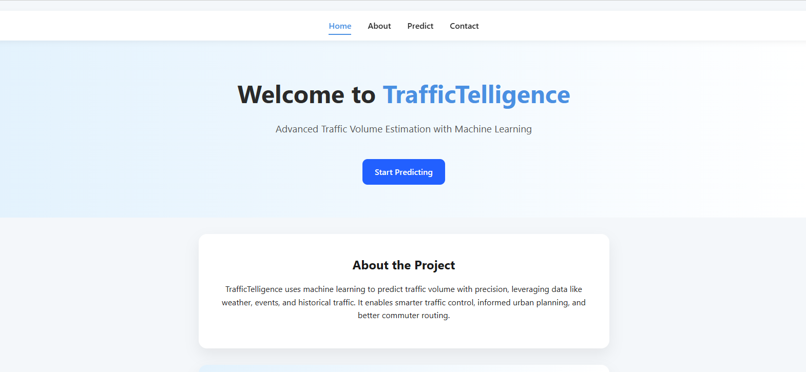TrafficTelligence is a machine learning-powered web-based application designed to predict traffic volume based on real-time and historical contextual data, including weather, holidays, time, and environmental variables. The platform provides timely and accurate traffic forecasts for city planners, commuters, and researchers, promoting smarter urban mobility and decision-making.

**1.2 Purpose**

The project aims to bridge the gap between static traffic reporting and predictive, actionable insights using modern ML approaches. By leveraging data-driven models, TrafficTelligence facilitates:

* Proactive congestion management
* Efficient route planning
* Enhanced urban mobility strategies

1. **Ideation Phase**

### **2.1 Problem Statement**

|  |  |
| --- | --- |
| Date | 26 June 2025 |
| Team ID | LTVIP2025TMID32353 |
| Project Name | TrafficTelligence |
| Maximum Marks | 2 Marks |

Urban traffic management remains a challenge due to unpredictable congestion spikes, weather disruptions, holiday surges, and limited forecasting tools. Current solutions are often reactive, expensive, or inaccessible to the general public. The need is for an intelligent, anticipatory framework that democratizes traffic prediction for all urban stakeholders.

|  |  |  |  |  |  |
| --- | --- | --- | --- | --- | --- |
| **Problem Statement (PS)** | **I am (Customer)** | **I’m trying to** | **But** | **Because** | **Which makes me feel** |
| PS-1 | A city planner or urban transportation authority responsible for managing and improving city traffic flow. | Anticipate peak congestion times and plan city infrastructure or interventions accordingly. | I lack predictive tools that integrate multiple real-world factors influencing traffic volume. | Existing solutions are either too generic, outdated, or do not utilize machine learning for advanced forecasting. | Limited in my ability to make data-driven decisions for urban mobility improvements. |

* 1. **Empathy Map Canvas**

|  |  |
| --- | --- |
| Date | 26 June 2025 |
| Team ID | LTVIP2025TMID32353 |
| Project Name | TrafficTelligence |
| Maximum Marks | 4 Marks |

**What do users THINK & FEEL?**

* Worry about being late to important events
* Stress regarding unexpected jams
* Desire for reliable, accurate travel time forecasts

**What do users SEE?**

* Traffic congestion updates on news or apps
* Road construction and weather changes
* Navigation apps with inconsistent advice

**What do users HEAR?**

* Complaints from friends/family about traffic
* Radio/TV updates about road conditions
* Suggestions to change routes or timings

**What do users SAY & DO?**

* Rant about daily traffic on social media
* Check multiple apps for the best route
* Adjust departure times or avoid certain roads

**PAIN**

* Delays from sudden congestion
* Lack of trust in traffic predictions
* Missed appointments

**GAIN**

* Predictable travel times
* Reduced stress and waiting
* Optimized personal schedules

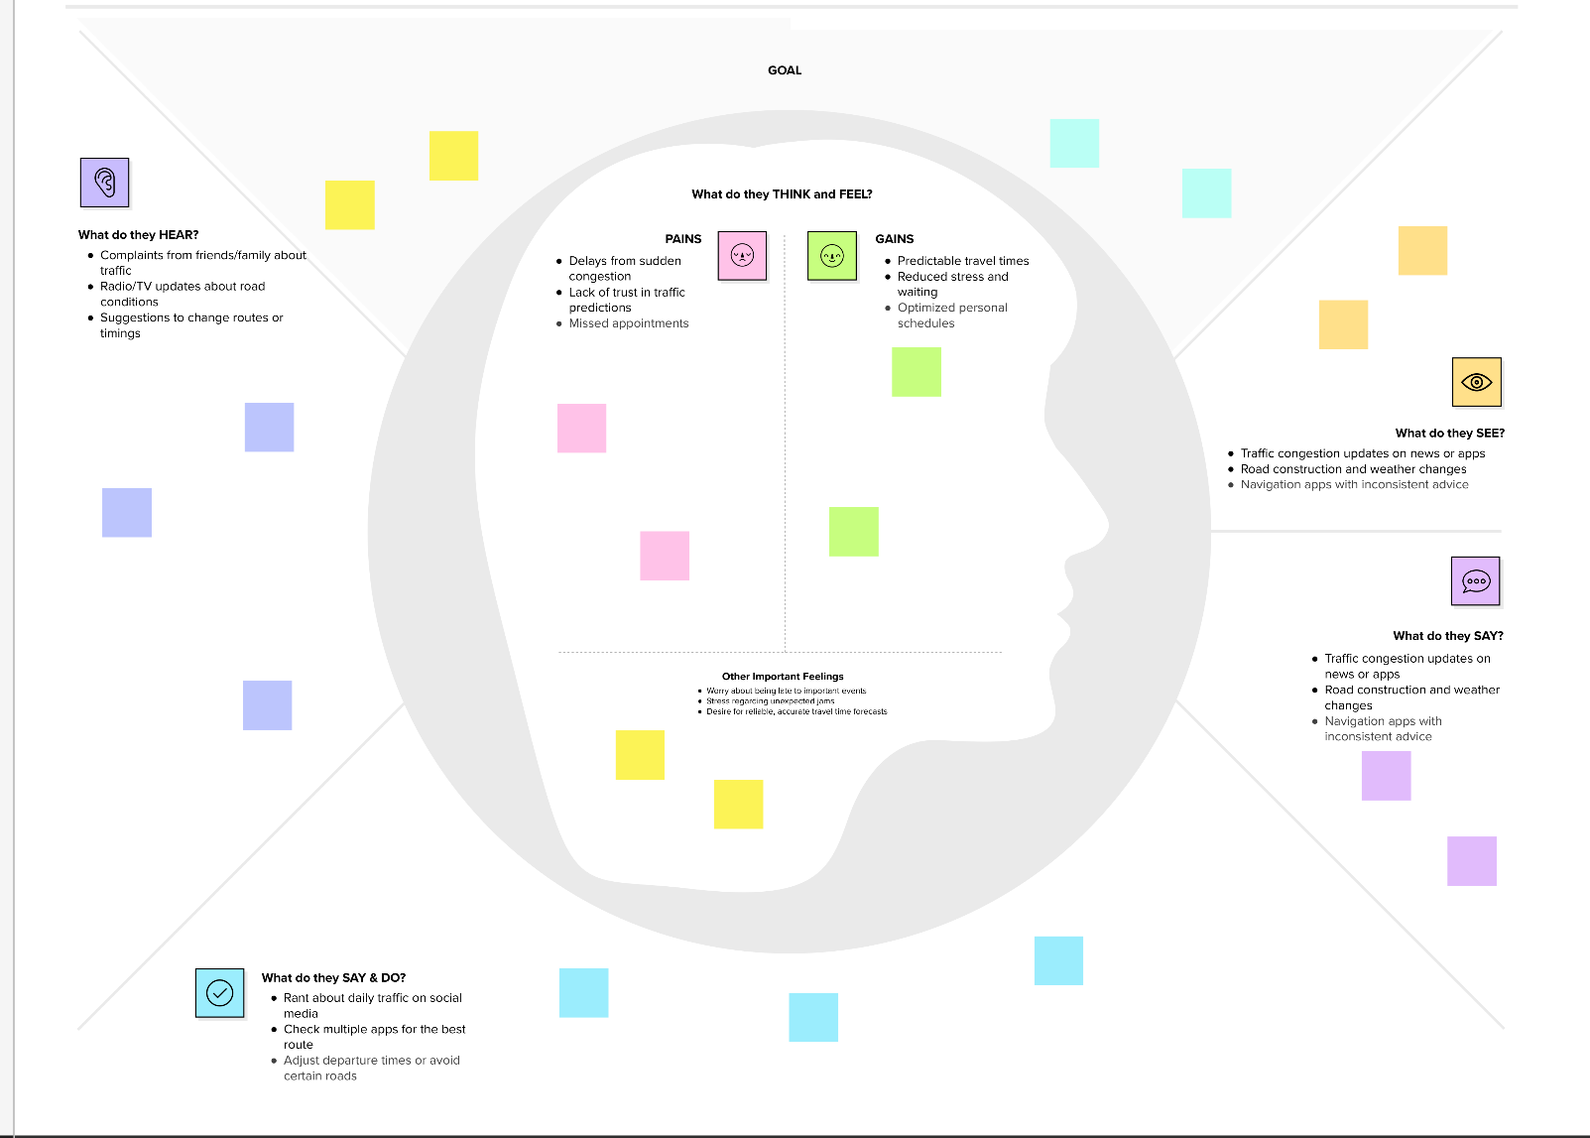

* 1. **Brainstorming**

|  |  |
| --- | --- |
| Date | 26 June 2025 |
| Team ID | LTVIP2025TMID32353 |
| Project Name | TrafficTelligence |
| Maximum Marks | 4 Marks |

**Step 1: Team Gathering, Collaboration, and Select the Problem Statement**

* The team assembled with diverse skills in data science, software development, and urban planning.
* Collaborative sessions were held to discuss real-world challenges in urban environments.
* Traffic prediction was unanimously selected as the problem statement due to its direct impact on daily life and the potential for public benefit.

**Step 2: Brainstorm, Idea Listing, and Grouping**

* Each team member contributed ideas on potential data sources, modeling techniques, and application features.
* Ideas included using weather APIs, integrating with city event calendars, and enabling user feedback.
* Similar ideas were grouped under broader categories such as "Data Enrichment," "User Experience," and "Modeling Approach."

**Step 3: Idea Prioritization**

* Ideas were prioritized based on feasibility, impact, and available resources.
* Highest priority was given to features with immediate user benefit:
  + Real-time prediction via a web interface
  + Inclusion of key input fields (weather, holiday, time)
  + Robust and interpretable ML model
* Lower-priority or future-phase ideas (e.g., mobile app, multi-city support) were recorded for the product roadmap.

**3. Requirement Analysis**

**3.1 Customer Journey Map**

**Phases & Steps**

| **Phase** | **Steps** | **Interactions** | **Goals & Motivations** | **Positive Moments** | **Negative Moments** | **Areas of Opportunity** |
| --- | --- | --- | --- | --- | --- | --- |
| Entice | Hears about TrafficTelligence from a friend or social media | Shares with peers | Wants to avoid traffic | Learns about an easy tool | Initial skepticism | Targeted onboarding |
| Enter | Visits the web app | Navigates menu, tries demo | Seeks accurate prediction | Simple interface | Unclear input fields | UI improvements |
| Engage | Inputs data (date, time, weather, holiday) | Interacts with form, asks for help | Efficient planning | Fast results, easy correction | Incorrect data entry | Live validation |
| Exit | Receives prediction, plans route | Shares prediction, gives feedback | Save time, avoid jams | Accurate, useful advice | Mismatch with actual conditions | Data/API integration |
| Extend | Recommends to others, repeats use | Follows up with feedback | Continued value | Consistency in results | Diminishing novelty | Loyalty features |

**3.2 Solution Requirements (Functional & Non-functional)**

|  |  |
| --- | --- |
| Date | 26 June 2025 |
| Team ID | LTVIP2025TMID32353 |
| Project Name | TrafficTelligence |
| Maximum Marks | 4 Marks |

**Functional Requirements:**

Following are the functional requirements of the proposed solution.

|  |  |  |
| --- | --- | --- |
| **FR No.** | **Functional Requirement (Epic)** | **Sub Requirement (Story / Sub-Task)** |
| FR-1 | User Input & Interface | Data entry for weather, date, time, holiday |
| FR-2 | Prediction Engine | ML model integration, real-time prediction |
| FR-3 | Data Preprocessing | Input encoding, scaling, validation |
| FR-4 | Results Display | Output prediction, error handling |
| FR-5 | Contact & Feedback | Contact/feedback form, message logging |
| FR-6 | Admin Dashboard (future) | Usage analytics, feedback review |

**Non-functional Requirements:**

Following are the non-functional requirements of the proposed solution.

|  |  |  |
| --- | --- | --- |
| **FR No.** | **Non-Functional Requirement** | **Description** |
| NFR-1 | Usability | Clean, intuitive UI for all age groups |
| NFR-2 | Security | No sensitive data stored; secure forms |
| NFR-3 | Reliability | High prediction uptime, robust fallback |
| NFR-4 | Performance | <2s response for predictions |
| NFR-5 | Scalability | Modular codebase for new features/cities |

**3.3 Data Flow Diagram**

|  |  |
| --- | --- |
| Date | 26 June 2025 |
| Team ID | LTVIP2025TMID32353 |
| Project Name | TrafficTelligence |
| Maximum Marks | 4 Marks |

Data Flow Diagram Shows how the data flows in order to show the volume Of the traffic. The below is the data flow diagram that illustrates how the data flows

**Flow Chart**

**User Input**

**Flask Web UI**

**Data Preprocessing**

**ML Model (Random Forest)**

**Traffic Prediction**

**Output to User**

**3.4 Technology Stack**

|  |  |
| --- | --- |
| Date | 26 June 2025 |
| Team ID | LTVIP2025TMID32353 |
| Project Name | TrafficTelligence |
| Maximum Marks | 4 Marks |

* **Frontend:** HTML5, CSS3
* **Backend:** Python 3.x (Flask)
* **ML:** scikit-learn (Random Forest), pandas, numpy
* **Data Storage:** CSV for training; Pickle (.pkl) for model/encoder
* **Deployment:** Localhost

**4. Project Design**

**4.1 Problem Solution Fit**

|  |  |
| --- | --- |
| Date | 26 June 2025 |
| Team ID | LTVIP2025TMID32353 |
| Project Name | TrafficTelligence |
| Maximum Marks | 2 Marks |

TrafficTelligence offers a cost-effective, scalable, and user-friendly alternative to expensive sensor-based traffic systems. By utilizing open data and machine learning, it enables predictive traffic analysis for all urban stakeholders.

**4.2 Proposed Solution**

|  |  |
| --- | --- |
| Date | 26 June 2025 |
| Team ID | LTVIP2025TMID32353 |
| Project Name | TrafficTelligence |
| Maximum Marks | 2 Marks |

| **S.No.** | **Parameter** | **Description** |
| --- | --- | --- |
| 1. | Problem Statement (Problem to be solved) | Urban commuters and city planners face persistent challenges due to unpredictable traffic congestion, resulting in lost productivity, stress, and inefficient resource allocation. There is a lack of accessible, predictive tools that factor in real-world conditions like weather and holidays. |
| 2. | Idea / Solution Description | Develop "TrafficTelligence"—a machine learning-based web application that predicts traffic volume using contextual data such as weather, time, and holidays. Users input relevant details to support smart commuting and urban planning decisions. |
| 3. | Novelty / Uniqueness | Unlike traditional reactive traffic tools, TrafficTelligence offers proactive, ML-driven predictions by integrating multiple real-world factors. The platform requires minimal infrastructure, is accessible via web/mobile, and can be tailored for various cities or regions. |
| 4. | Social Impact / Customer Satisfaction | Reduces commuter frustration, improves punctuality, decreases fuel consumption, and contributes to smoother urban mobility. City planners gain better tools for data-driven decision-making, positively impacting the community at large. |
| 5. | Business Model (Revenue Model) | Free basic access for the public. Advanced analytics, API integrations, and custom dashboards can be offered as premium features for businesses, municipalities, or logistics providers on a subscription or pay-per-use basis in future |
| 6. | Scalability of the Solution | Designed to be modular and extendable: new cities, data sources, and ML models can be added easily. Can scale horizontally to handle increased user load and integrate with third-party APIs for live data, supporting both small towns and large metropolitan areas. |

**4.3 Solution Architecture**

|  |  |
| --- | --- |
| Date | 26 June 2025 |
| Team ID | LTVIP2025TMID32353 |
| Project Name | TrafficTelligence |
| Maximum Marks | 4 Marks |

* **Frontend** (HTML/CSS): User input forms, result display, info pages
* **Backend** (Flask):
  + Routes: /, /about, /inspect, /contact, /predict
  + Handles input validation, encoding, model inference
* **ML Model**: Random Forest trained on historical traffic data, serialized with Pickle
* **Preprocessing**: Label encoding, scaling, error handling

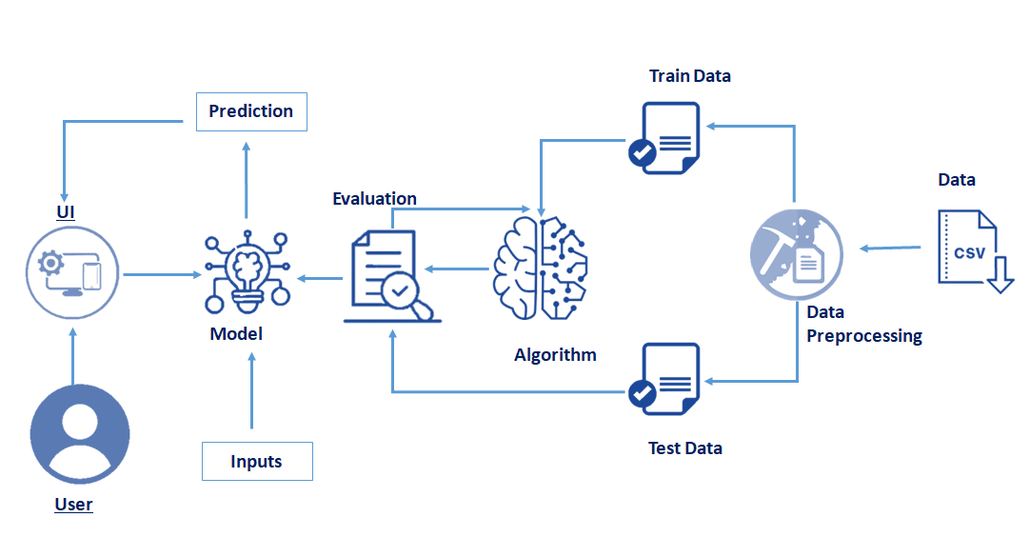

**5. Project Planning & Scheduling**

|  |  |
| --- | --- |
| Date | 26 June 2025 |
| Team ID | LTVIP2025TMID32353 |
| Project Name | TrafficTelligence |
| Maximum Marks | 5 Marks |

**Member 1 ->** Data Preprocessing

**Member 2 ->** Model Building

**Member 3 ->** Frontend

**Member 4 ->** Backend

**Product Backlog**

| **Epic (Functional Requirement)** | **User Story Number** | **User Story / Task** | **Story Points** | **Priority** | **Assigned To** |
| --- | --- | --- | --- | --- | --- |
| Data Collection | USN-1 | Gather and load historical traffic/contextual data | 2 | High | Member 1 |
| Data Preprocessing | USN-2 | Preprocess data (handle missing/categorical values) | 3 | High | Member 1 |
| Model Building | USN-3 | Build ML model for traffic prediction | 5 | High | Member 2 |
| Model Evaluation | USN-4 | Test and evaluate the ML model | 3 | High | Member 2 |
| Backend API | USN-5 | Develop Flask backend and REST API | 4 | High | Member 4 |
| Frontend/Dashboard | USN-6 | Implement user-friendly web dashboard (HTML/CSS/JS) | 4 | Medium | Member 3 |
| Integration | USN-7 | Integrate backend API with frontend | 2 | High | Member 3,  Member 4 |
| Scenario Simulation | USN-8 | Allow users to simulate traffic for custom dates/events | 2 | Medium | Member 2  Member 4  Member 3 |

**Sprint Schedule & Estimation**

**Sprint-1 (10 June – 15 June)**

| **User Story Number** | **Task** | **Story Points** | **Assigned To** |
| --- | --- | --- | --- |
| USN-1 | Data collection and loading | 2 | Member 1 |
| USN-2 | Data preprocessing (missing/categorical) | 3 | Member 1 |
| USN-3 | Model building | 3 | Member 2 |
|  | **Total** | **8** |  |

**Sprint-2 (16 June – 21 June)**

| **User Story Number** | **Task** | **Story Points** | **Assigned To** |
| --- | --- | --- | --- |
| USN-4 | Model evaluation | 3 | Member 2 |
| USN-5 | Backend API scaffolding & endpoints | 3 | Member 1 |
| USN-6 | Frontend dashboard basic layout | 2 | Member 3 |
| USN-7 | API-frontend integration | 2 | Member 3,  Member 4 |
|  | **Total** | **10** |  |

**Sprint-3 (22 June – 28 June)**

| **User Story Number** | **Task** | **Story Points** | **Assigned To** |
| --- | --- | --- | --- |
| USN-6 | Frontend UI enhancements | 2 | Member 3 |
| USN-8 | Scenario simulation logic | 2 | Member 2,  Member 4 |
| USN-9 | Feedback/contact form | 1 | Member 3 |
| USN-10 | Documentation | 2 | All |
|  | Polish, bug fixes, final testing | 2 | All |
|  | **Total** | **9** |  |

**Total Story Points: 8 + 10 + 9 = 27**

**Velocity**

Total Story Points =27

Total Number of Sprints =3

Velocity = 27/3 =9

**Team’s Velocity is 9**

**Sprint Tracker**

| **Sprint** | **Story Points Planned** | **Story Points Completed** | **Start Date** | **Planned End Date** | **Actual End Date** | **Comments** |
| --- | --- | --- | --- | --- | --- | --- |
| Sprint-1 | 8 | 8 | 10-Jun-2025 | 15-Jun-2025 | 15-Jun-2025 |  |
| Sprint-2 | 10 | 10 | 16-Jun-2025 | 21-Jun-2025 | 21-Jun-2025 |  |
| Sprint-3 | 9 | 9 | 22-Jun-2025 | 28-Jun-2025 | 28-Jun-2025 |  |

**6. Performance Testing**

|  |  |
| --- | --- |
| Date | 26 June 2025 |
| Team ID | LTVIP2025TMID32353 |
| Project Name | TrafficTelligence |
| Maximum Marks | 10 Marks |

|  |  |  |  |
| --- | --- | --- | --- |
| **S.No.** | **Parameter** | **Values** | **Screenshot** |
|  | Metrics | **Regression Model:** MAE - , MSE - , RMSE - , R2 score - |  |
|  | Tune the Model | Hyperparameter Tuning -  Validation Method - |  |

**7. Results**

**7.1 Model Performance**

* ** R2 score:**
* **Prediction sample:**
  + **Input:**

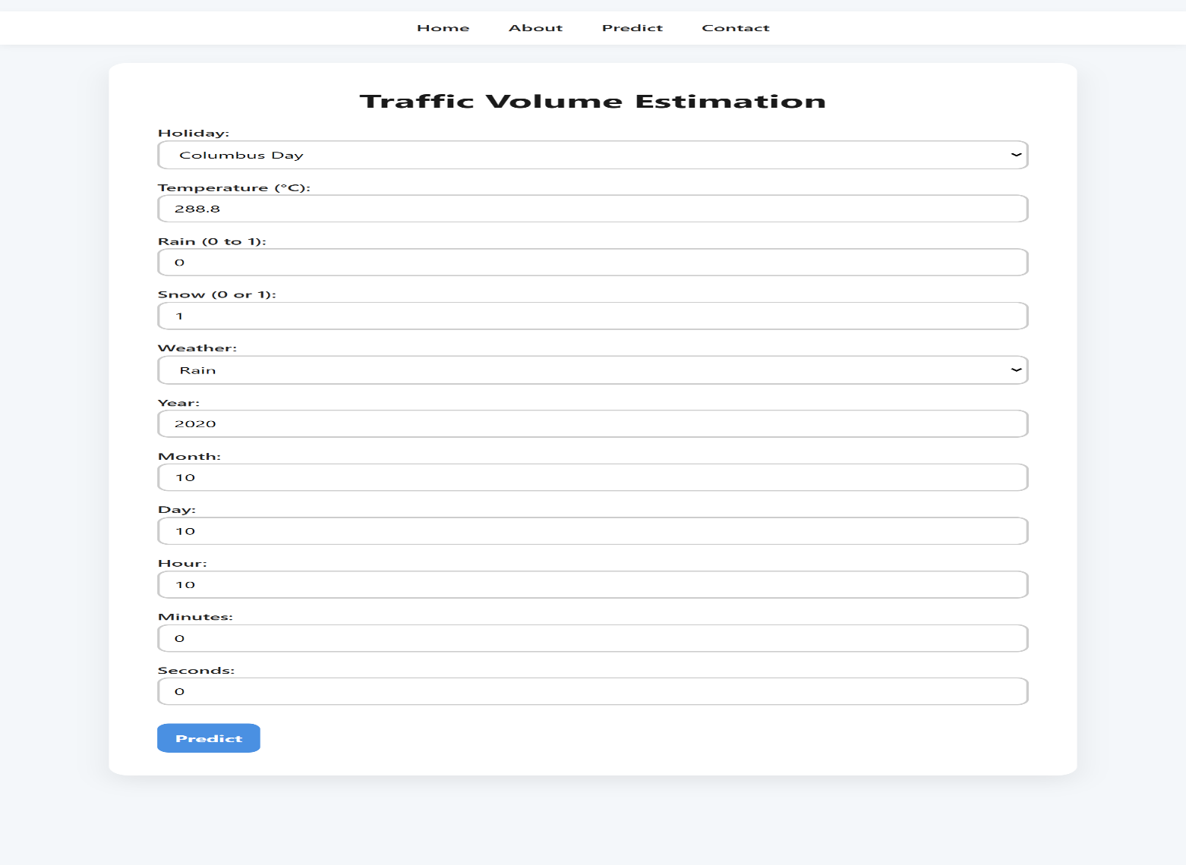

* + 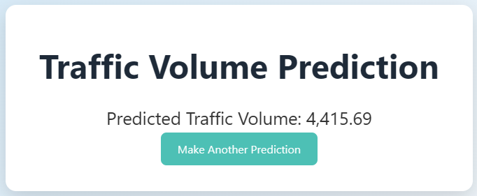**Output: Predicted Traffic Volume:**

**7.2 User Interface**

* + 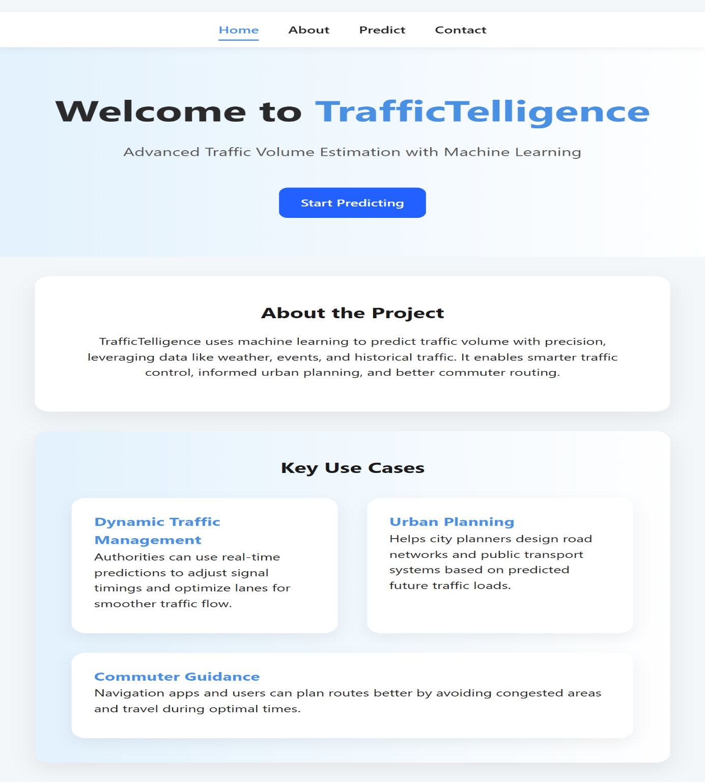**Home Page**
  + 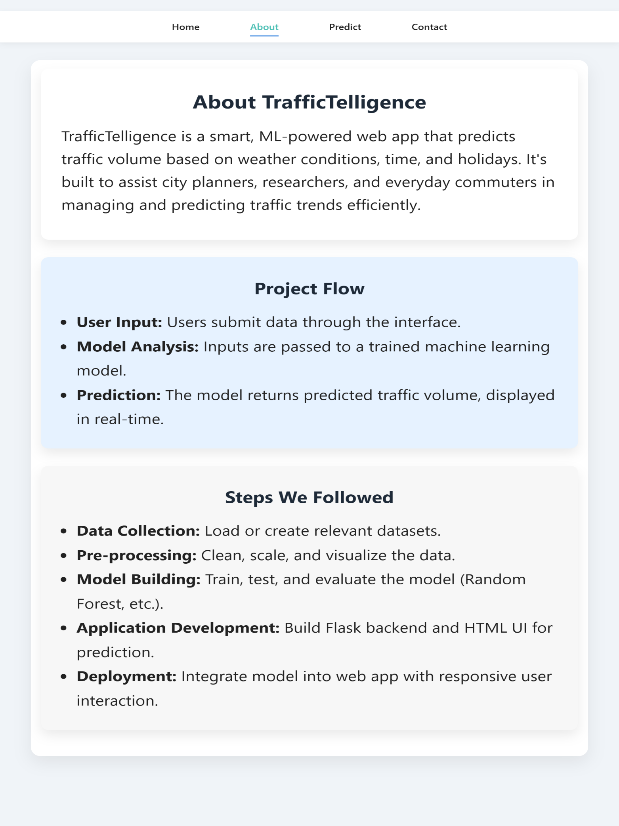**About Page**
  + 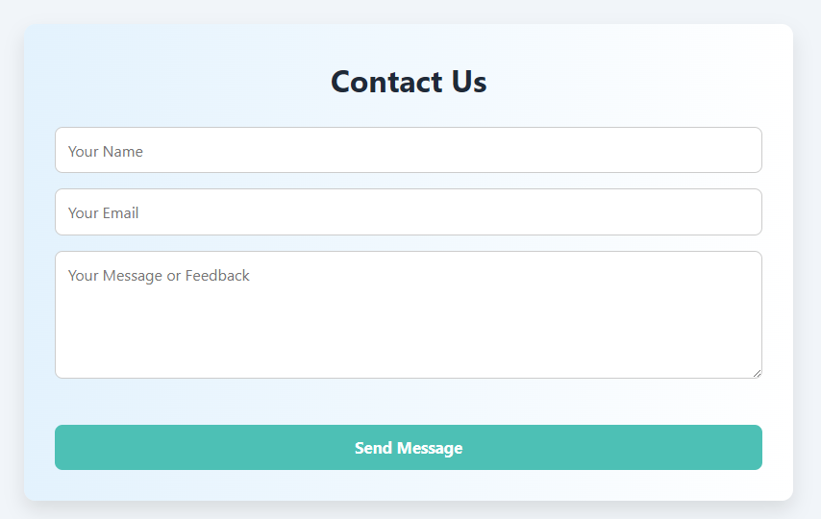**Contact Page**

**8. Advantages & Disadvantages**

**8.1 Advantages**

* Real-time, accurate traffic predictions
* Low-cost, scalable solution
* Intuitive web interface
* Extensible for future enhancements

**8.2 Disadvantages**

* ML model accuracy depends on data quality/coverage
* May require regular retraining for different cities

**9. Conclusion**

TrafficTelligence provides a robust, scalable approach for predicting urban traffic volume using machine learning. Its accessible web interface democratizes predictive analytics for both authorities and the general public, paving the way for smarter city mobility.

**10. Future Scope**

* Integration with live APIs (weather, traffic)
* Mobile app development
* Support for multiple cities/countries
* Predictive analytics for special events/disasters
* Advanced visualizations (heatmaps, time series)

**11. Appendix**

**Source Code**

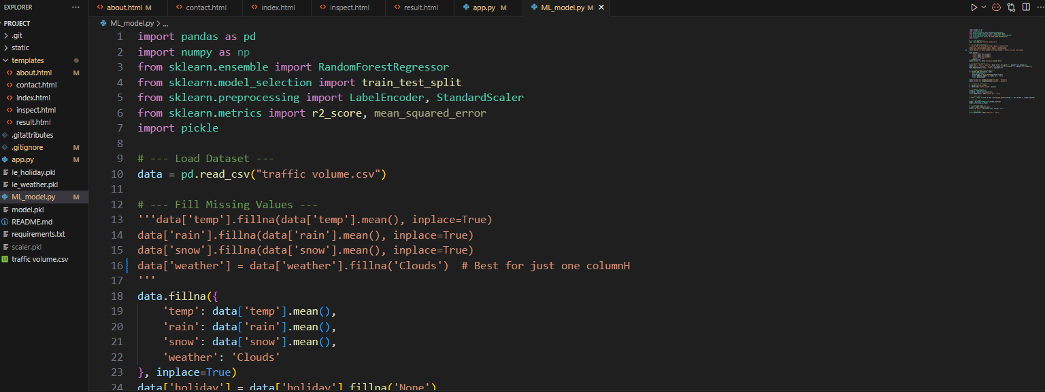

11.1)Model.py

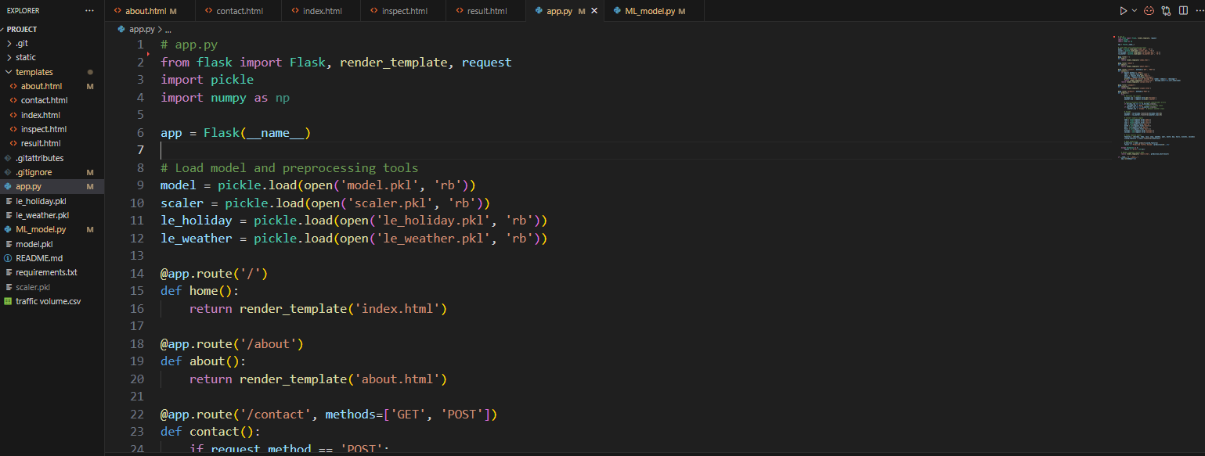

11.2)app.y

**Data Set Link**

Click to preview the data set -> [Data Set](https://drive.google.com/file/d/1iV5PfYAmI6YP0_0S4KYy1ZahHOqMgDbM/view)

**Git Hub Link**

Click to preview the Git Hub Repo -> [Git Hub Repo](https://github.com/Shethu-12/TrafficTelligence)

**Project Demo Link**

Click to preview the Project Demo Link -> [Demo Vedio](https://drive.google.com/file/d/1QNhXKaC0XlcVZWC8xwcGbPJmUzFSUuja/view?usp=drivesdk)

**The End**